

**AMERICAN INTERNATIONAL UNIVERSITY**

**BANGLADESH**

COURSE: Introduction To Database

Section : F

**Project Name: Food Delivery & Management System**

GROUP NAME: UNITED CODERS

**Group Member             -           Id**

1. Sharia Tasnim Adrita - 20-41895-1
2. Faiza Tasnim - 19-41552-3
3. Mohd. Yah-Ya Raiyan - 19-41752-3
4. Sadia Afrin Sara - 20-41834-1

|  |
| --- |
| **Table of Content** |
| * Case Study |
| * ER Diagram |
| * Normalization |
| * Table creation |
| * Table Insertion |
| * Subquery |
| * Joining |
| * Group Function |
| * Single Row Function |
| * View |
| * Sequence |

**Case Study**

In a food delivery management system, the customer places their order staying at home or anywhere and the vendors hire a delivery man who delivers the food to the customer addresses. A customer order food by food_name, price, type,quantity and item_name. After receiving the order customer pays bill. one customer can order many food items also a deliveryman can deliver to many customers. Both the customer and the delivery man is identified by their name, email and address. The system holds the basic information for both the Customer and Vendor; such as name, phone number, location etc. So the relationship between the customer and the vendor is Transaction. The system collects information of customer’s id, name, email, location, phone number. The vendor may also have the information like as TIN number, Shop name, Location, phone number. Payment can be cash out delivery and online payment. Then, delivery man places order to customer delivery status contains departure time and arrival time.

**ER Diagram:**

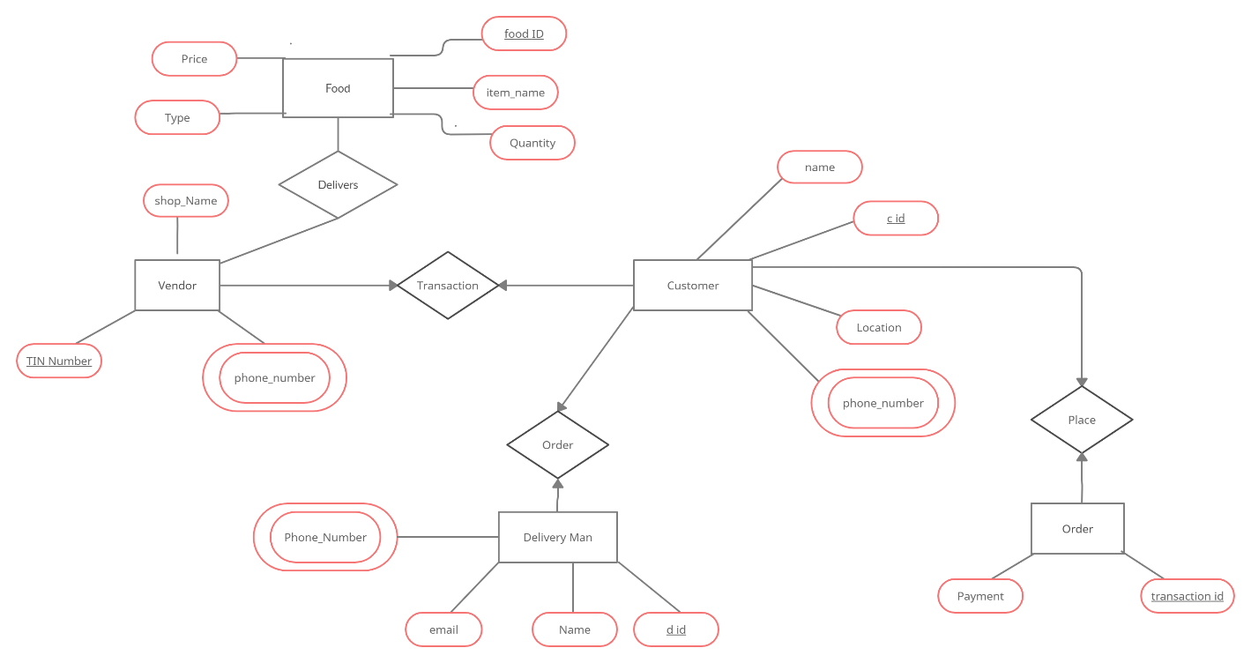

**Normalization:**

**Transaction** (TIN number , shop_name, phone number,name, location,c_id)

**1NF:**

phone number multivalued attribute

**2NF:**

TIN number, phone number, shop_name

c_id ,name, phone number,location

TC_id,TIN number ,c_id

**3NF:**

TIN number, phone number, shop_name

c_id ,name, phone number,location

TC_id,TIN number ,c_id

No transitive dependency

**Table:**

TIN number, phone number, shop_name

c_id ,name, phone number,location

TC_id,TIN number ,c_id

**Order**(c_id,name,location,phone_number,d_id,email,name,phone_number)

**1NF:**

Phone number  multivalued attribute

**2NF:**

c_id , name,location, phone number

d_id, email, name, phone_number

CD_id,d_id,c_id

**3NF:**

c_id , name,location, phone number

d_id, email, name, phone_number

CD_id,d_id,c_id

No transitive dependency

**Table:**

c_id , name,location, phone number

d_id, email, name, phone_number

CD_id,d_id,c_id

**Places (**name,location , phone_number,c_id, payment , transaction_id**)**

**1NF:**

  Phone number multivalued attribute

**2NF:**

c_id, name, location, phone_number

Transaction_id,Payment

CT_id,C_id, Transaction_id

**3NF:**

C_id, name, location, phone_number

Transaction_id,Payment

CT_id,C_id, Transaction_id

 No transitive dependency

**Table:**

C_id, name, location, phone_number

Transaction_id,Payment

CT_id,c_id, Transaction_id

**Delivers** (food_id, price, type, item_name, quantity, TIN_number, phone_number,shop_name)

**1NF:**

Phone number multivalued attribute.

**2NF:**

Food_id, price, type, item_name, quantity

TIN_number, phone_number,shop_name

**3NF:**

Food_id, price, type, item_name, quantity

TIN_number, phone_number,shop_name

**Table:**

Food_id, price, type, item_name, quantity

TIN_number, phone_number,shop_name

**Total Table:**

TIN number, phone number, shop_name

c_id ,name, phone number,location

TC_id,TIN number ,c_id

~~c_id , name,location, phone number~~

d_id, email, name, phone_number

CD_id,d_id,c_id

~~c_id, name, location, phone_number~~

Transaction_id,Payment

CT_id,c_id, Transaction_id

Food_id, price, type, item_name, quantity

~~TIN_number, phone_number,shop_name~~

**Final Table:**

TIN number, phone number, shop_name

c_id ,name, phone number,location

TC_id,TIN number ,c_id

d_id, email, name, phone_number

CD_id,d_id,c_id

Transaction_id,Payment

CT_id,c_id, Transaction_id

Food_id, price, type, item_name, quantity

**Table Creation:**

**1**. Create table TIN_info

(

TIN_number number(10) CONSTRAINT TIN_PK PRIMARY KEY,

Phone_number number(11) NOT NULL,

shop_name varchar2(70) NOT NULL

)

desc TIN_info

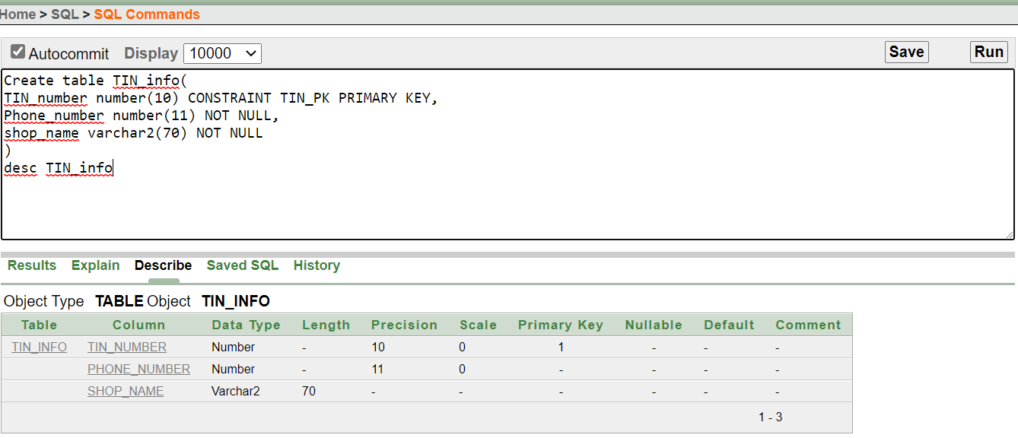

**2.** Create table customer_info

(

c_id number(10) CONSTRAINT customer_PK PRIMARY KEY,

name varchar2 (50) NOT NULL,

Phone_number number (11) NOT NULL,

Location varchar2(80) NOT NULL

)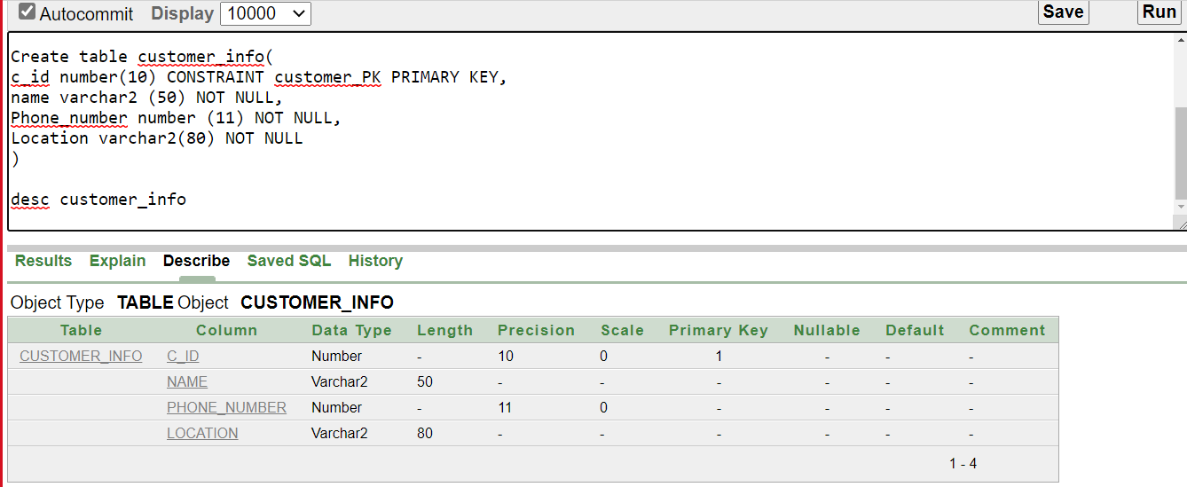

**3.** Create table TC_info

(

TC_id number (10) CONSTRAINT TC_id_PK PRIMARY KEY,

TIN_number number(10) CONSTRAINT TC_TIN_FK REFERENCES TIN_info (TIN_number),

c_id number(10) CONSTRAINT TC_c_id_FK REFERENCES customer_info (c_id)

)

desc TC_info

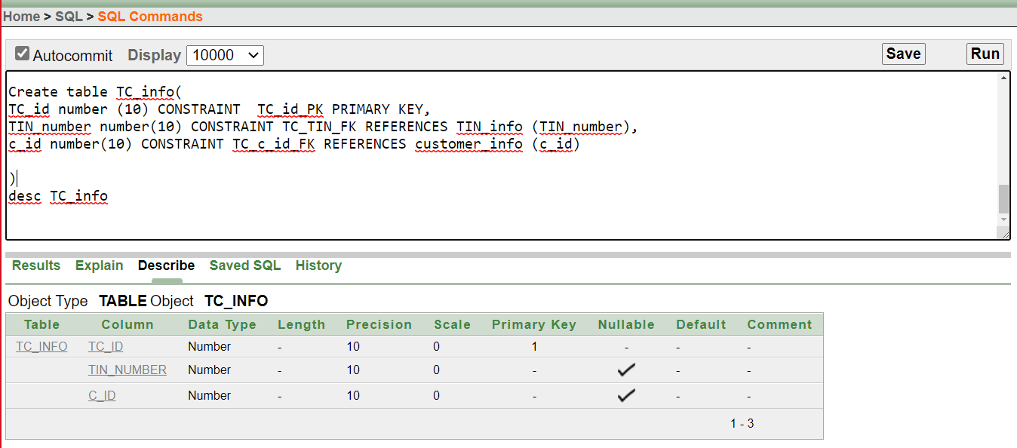

**4.** Create table delivery_man_info

(

did number(5) CONSTRAINT d_PK PRIMARY KEY,

email varchar2(30) NOT NULL,

name varchar2(30) NOT NULL,

phone_number number(11) NOT NULL

)

desc delivery_man_info

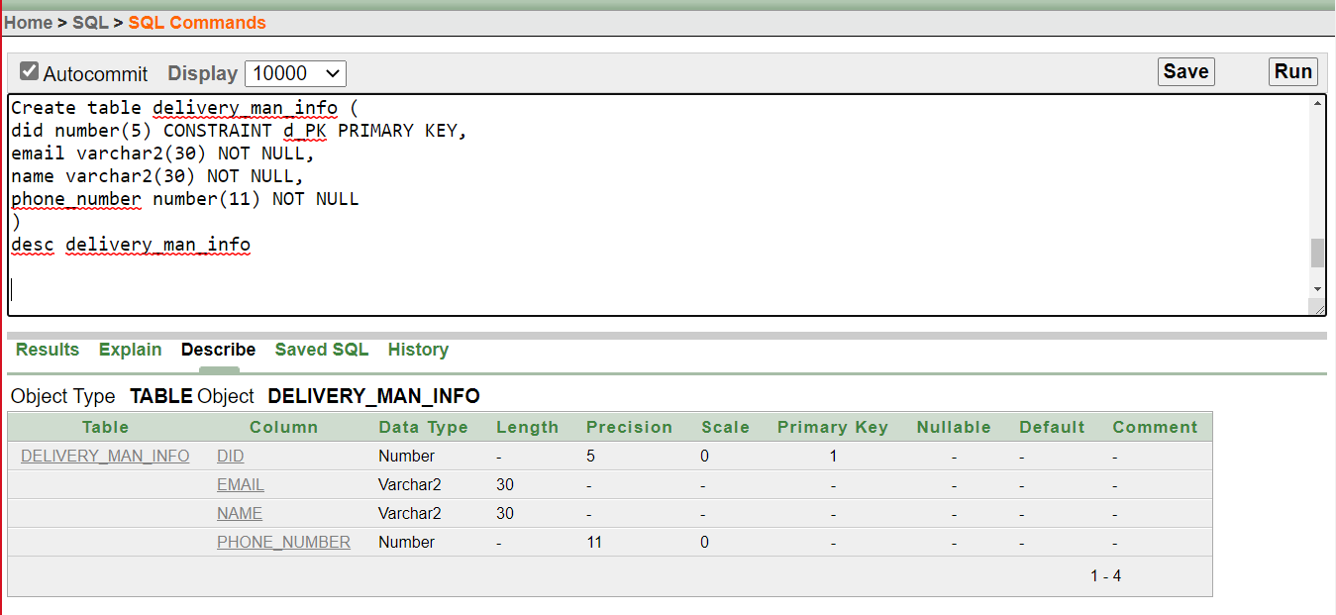

**5.** Create table CD_info

(

CD_id number(10) CONSTRAINT CD_PK PRIMARY KEY,

c_id number(10) CONSTRAINT CD_c_id_FK REFERENCES customer_info(c_id),

did number(10) CONSTRAINT CD_d_id_FK REFERENCES delivery_man_info(did)

)

desc CD_info

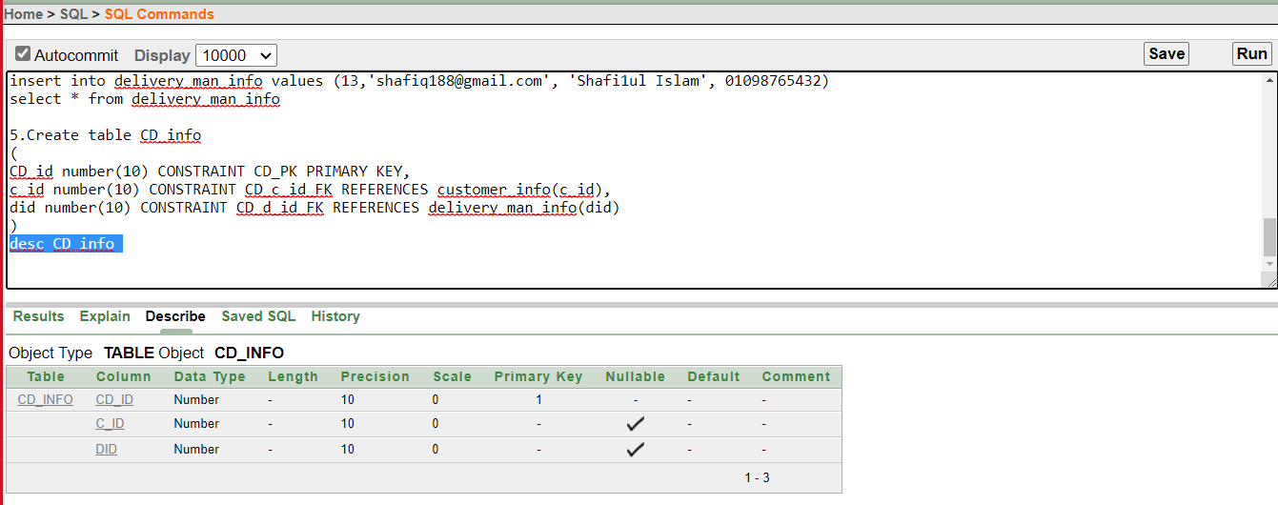

**6.** Create table orderPlace_info

(

Transaction_id number(10) CONSTRAINT TRN_PK PRIMARY KEY,

Payment varchar2(50) CONSTRAINT order_payment_ck check (Payment in('Cash on delivery', 'Online'))

)

desc orderPlace_info

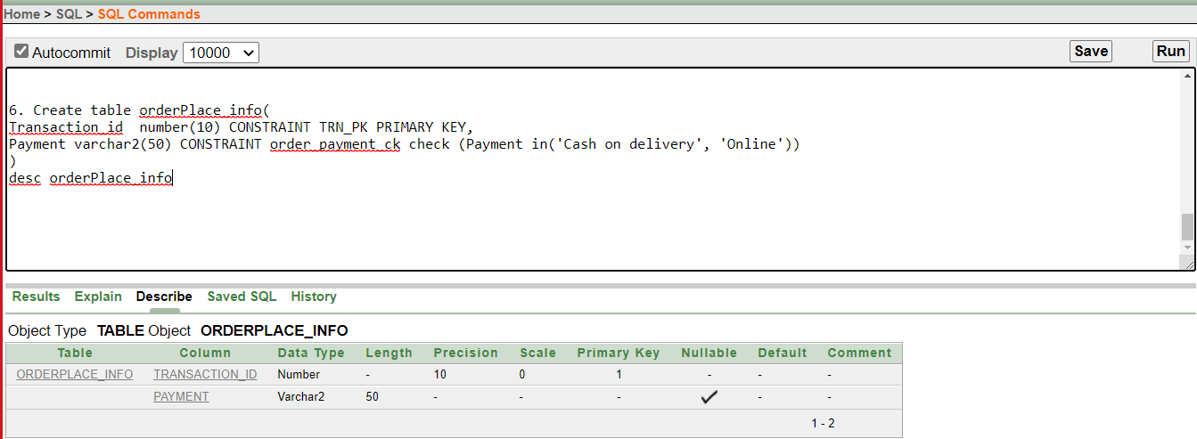

**7.** Create table CT_id_info

(

CT_id number(10) CONSTRAINT CT_PK PRIMARY KEY,

c_id number(10) CONSTRAINT CTINFO_c_id_FK REFERENCES customer_info (c_id),

Transaction_id number(10) CONSTRAINT CTINFO_TRANSACTION_FK REFERENCES orderPlace_info(Transaction_id)

)

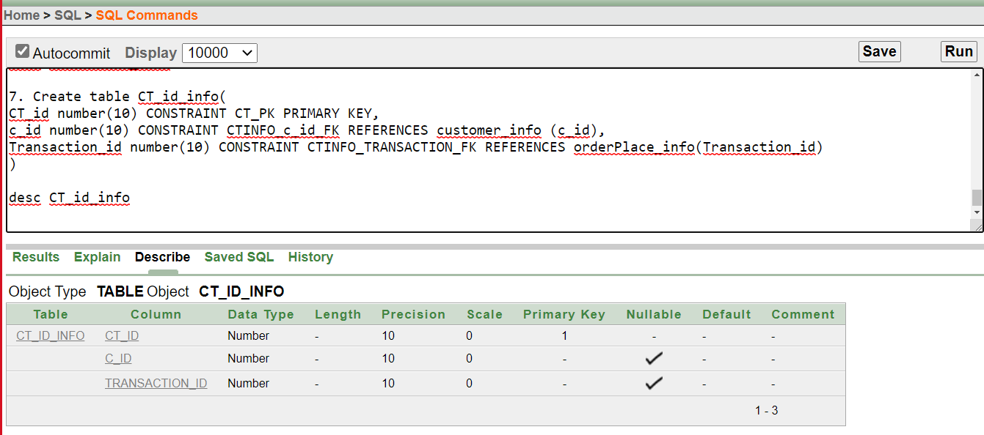

**8.**

Create table food_info

(

food_id number(10) CONSTRAINT FOOD_INFO_ID_PK PRIMARY KEY,

price number(4) NOT NULL,

item_name varchar2 (70) NOT NULL,

quantity number(4) Default 1,

Type varchar2(50) CONSTRAINT food_info_CK CHECK(Type in('Platter', 'Set Menue''FastFood','Dinner','Desert','Drinks'

)

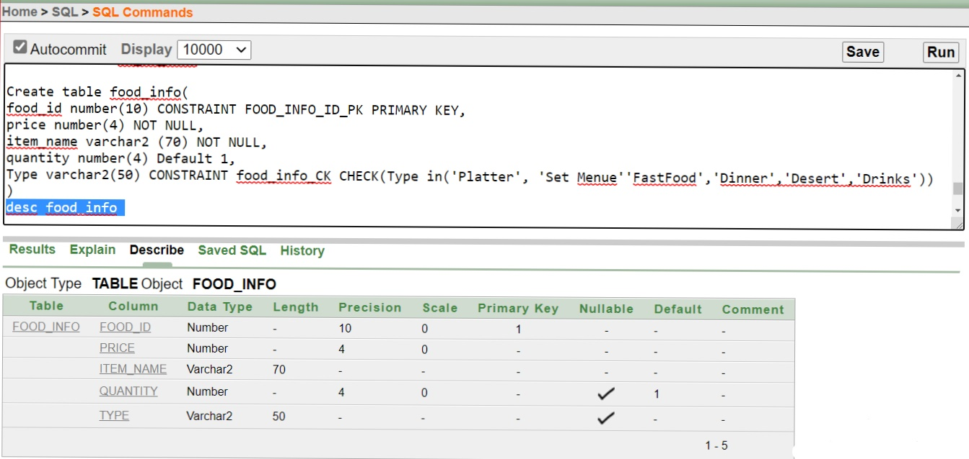

**Table Insertion**

**1.**

insert into TIN_info values (45685, 01978543267, 'TasteHackers')  
insert into TIN_info values (45656, 01578543267, 'Tastytreat')  
insert into TIN_info values (42386, 01378543267, 'sheramtaste')  
insert into TIN_info values (45486, 01878543267, 'kachchibhai')  
insert into TIN_info values (46786, 01578543267, 'hellokachchi')  
insert into TIN_info values (40001, 01778543267, 'terimeriteheri')  
insert into TIN_info values (40002, 01778543267, 'kababkhan')  
insert into TIN_info values (40003, 01478543267, 'pizzahut')  
insert into TIN_info values (40004, 01008543267, 'northern')  
insert into TIN_info values (40005, 01945543267, 'babarafi')

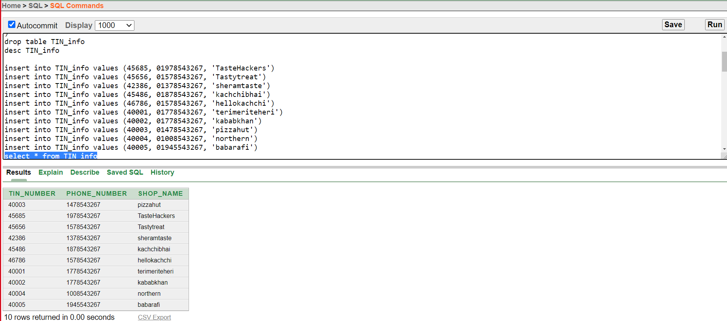

**2.**

insert into customer_info values(34567, 'Md Mahir', 01234567890, 'MohammadPur,Tajmahal Road, Block C')

insert into customer_info values(2001, 'dami Hossain', 01545678902, 'BashundharaR/A,Block A Street#07')

insert into customer_info values(2002, 'sami Hossain', 01655678902, 'BashundharaR/A,Block B Street#07')

insert into customer_info values(2003, 'rafi Hossain', 01765678902, 'BashundharaR/A,Block C Street#07')

insert into customer_info values(2004, 'rabbi Hossain', 04545678902, 'BashundharaR/A,Block D Street#07')

insert into customer_info values(2005, 'kafi Hossain', 01765678902, 'BashundharaR/A,Block E Street#07')

insert into customer_info values(2006, 'fabi Hossain', 08845678902, 'BashundharaR/A,Block F Street#07')

insert into customer_info values(2007, 'shaami Hossain', 22245678902, 'BashundharaR/A,Block G Street#07')

insert into customer_info values(2008, 'jason Hossain', 01655678902, 'BashundharaR/A,Block H Street#07')

insert into customer_info values(2009, 'butler Hossain', 017666678902, 'BashundharaR/A,Block I Street#07')

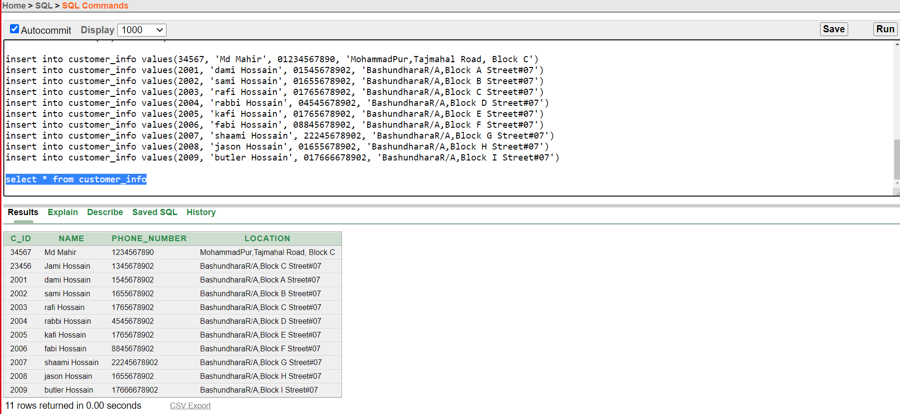

**3.**

insert into TC_info values (555,45656,2001)  
insert into TC_info values ( 777, 42386, 2002)  
insert into TC_info values (565,45486,2003)  
insert into TC_info values ( 888, 46786, 2004)  
insert into TC_info values (001,40001,2005)  
insert into TC_info values ( 002, 40002, 2006)  
insert into TC_info values (7,40003,2007)  
insert into TC_info values ( 004, 40004, 2008)  
insert into TC_info values (566,40005,2009)

insert into TC_info values ( 456, 45685, 34567)  
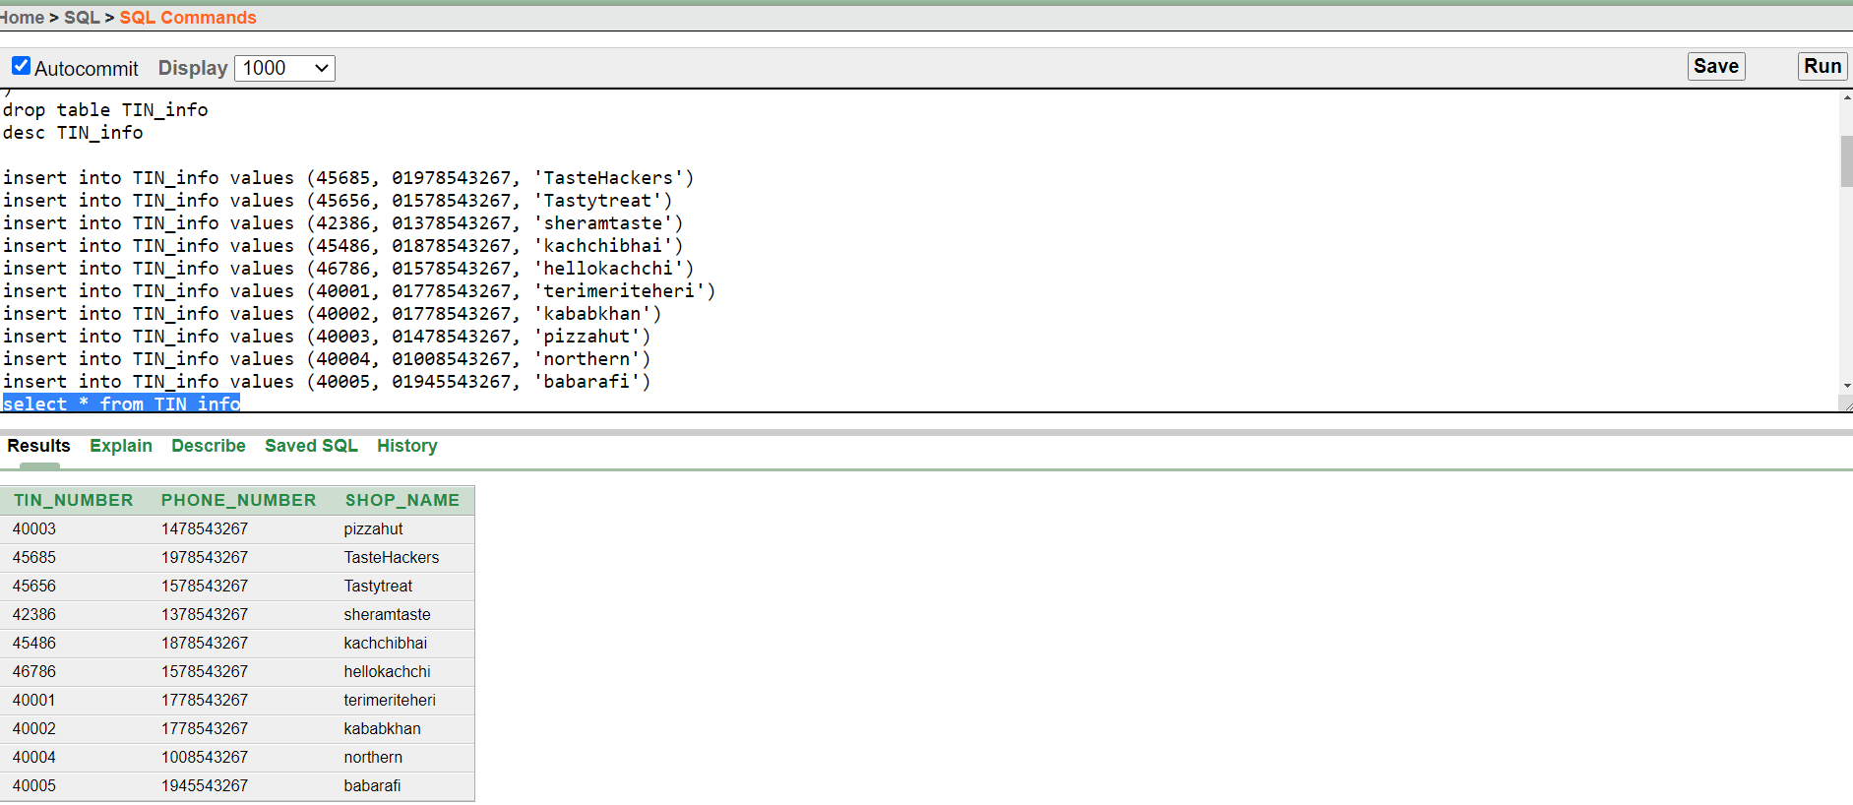

**4.**

insert into delivery_man_info values (1,'iqramhossain8@gmail.com', 'Iqram Hossain', 01234567543)  
insert into delivery_man_info values (2,'shafiq188@gmail.com', 'Shafi1ul Islam', 01098765432)  
insert into delivery_man_info values (3,'shafiq186@gmail.com', 'Shafl Islam', 0123456789)  
insert into delivery_man_info values (4,'fria88@gmail.com', 'faria Islam', 0213456789)  
insert into delivery_man_info values (5,'zerin188@gmail.com', 'zerin Islam', 0321456789)  
insert into delivery_man_info values (6,'didar88@gmail.com', 'didar Islam', 0432156789)  
insert into delivery_man_info values (7,'Sadman88@gmail.com', 'sadman', 054321789)  
insert into delivery_man_info values (8,'HERO188@gmail.com', 'Alam Islam', 0654321789)  
insert into delivery_man_info values (9,'saiful188@gmail.com', 'Shaiful Islam', 0765432189)  
insert into delivery_man_info values (10,'tuba88@gmail.com', 'tuba Islam', 0987654321)

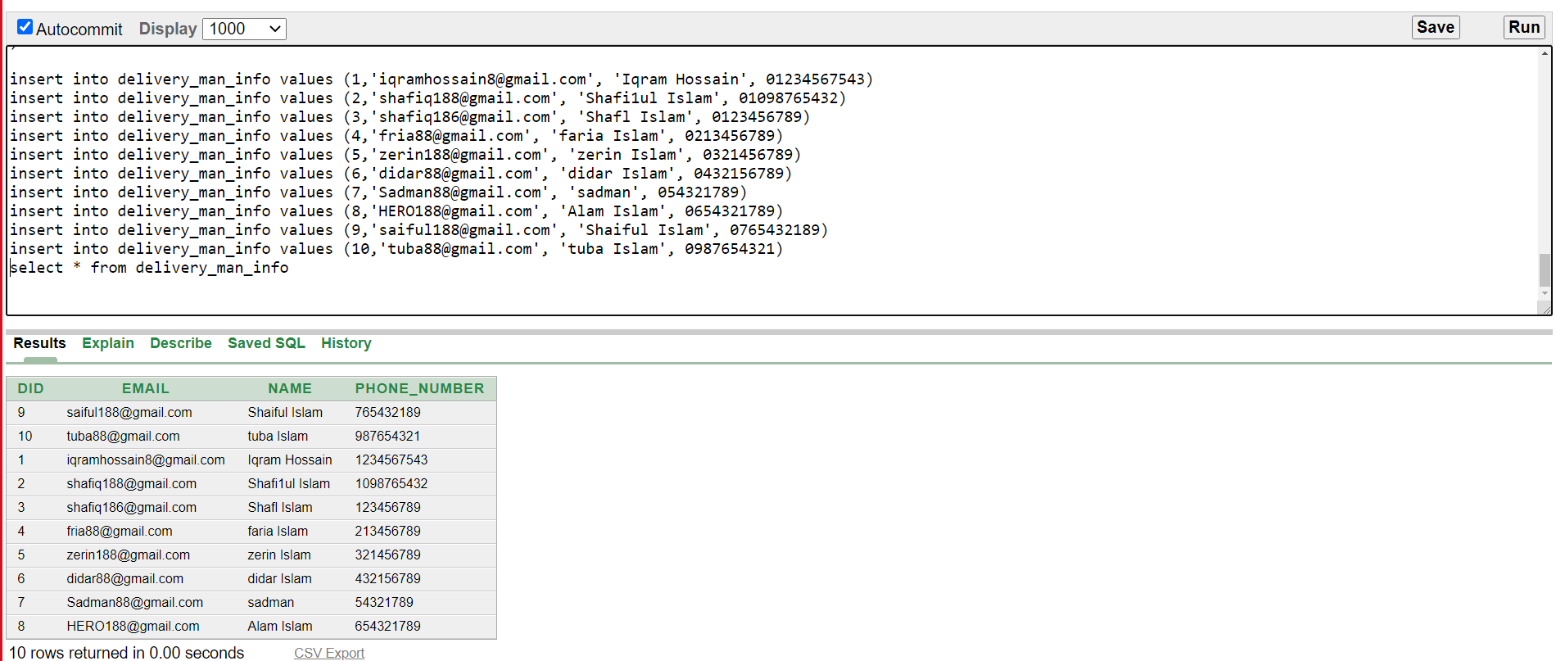

**5.**

insert into CD_info values (111, 34567 , 1)  
insert into CD_info values (112, 2001,2 )  
insert into CD_info values (113, 2002,3 )  
insert into CD_info values (114, 2003,4 )  
insert into CD_info values (115, 2004,5 )  
insert into CD_info values (116, 2005,6 )  
insert into CD_info values (117, 2006,7 )  
insert into CD_info values (118, 2007,8 )  
insert into CD_info values (119, 2008,9 )  
insert into CD_info values (110, 2009,10 )

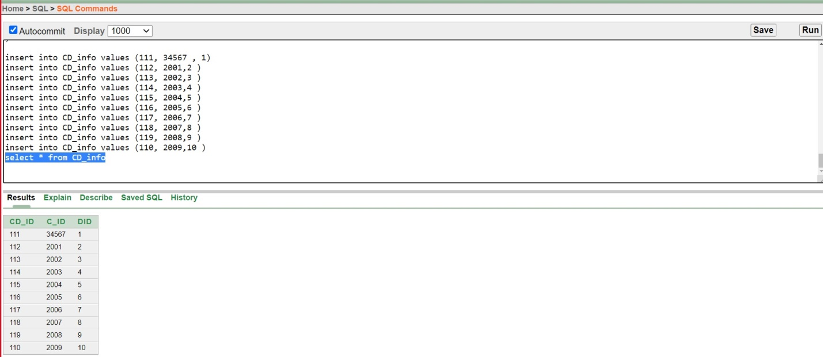

**6.**

insert into orderPlace_info values (6000, 'Cash on delivery')  
insert into orderPlace_info values (6001, 'Online')  
insert into orderPlace_info values (6002, 'Online')  
insert into orderPlace_info values (6003, 'Cash on delivery')  
insert into orderPlace_info values (6004, 'Cash on delivery')  
insert into orderPlace_info values (6005, 'Online')  
insert into orderPlace_info values (6006, 'Cash on delivery')  
insert into orderPlace_info values (6007, 'Online')  
insert into orderPlace_info values (6008, 'Cash on delivery')  
insert into orderPlace_info values (6009, 'Online')

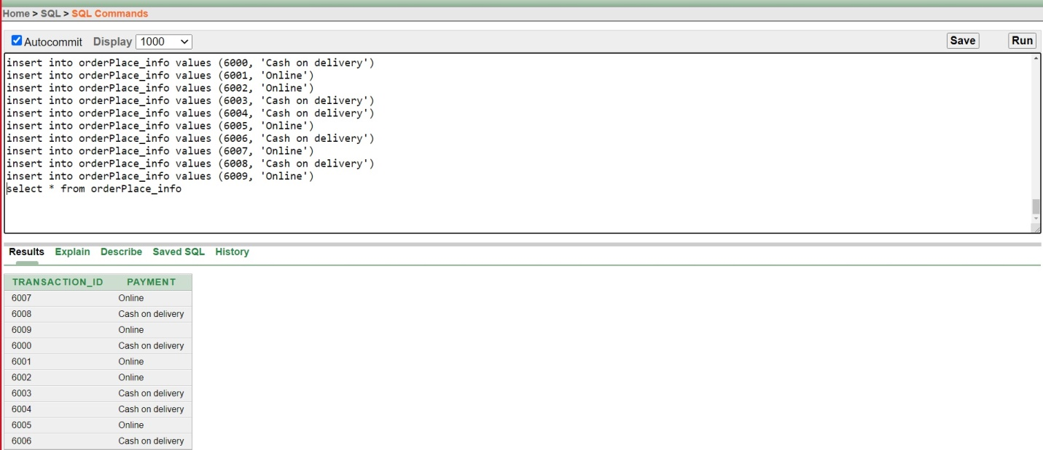

**7.**

insert into CT_id_info values (221, 34567,6000 )  
insert into CT_id_info values (222, 2001, 6001 )  
insert into CT_id_info values (223, 2002, 6002 )  
insert into CT_id_info values (224, 2003, 6003 )  
insert into CT_id_info values (225, 2004, 6004 )  
insert into CT_id_info values (226, 2005, 6005 )  
insert into CT_id_info values (227, 2006, 6006 )  
insert into CT_id_info values (228, 2007, 6007 )  
insert into CT_id_info values (229, 2008, 6008 )  
insert into CT_id_info values (220, 2009, 6009 )

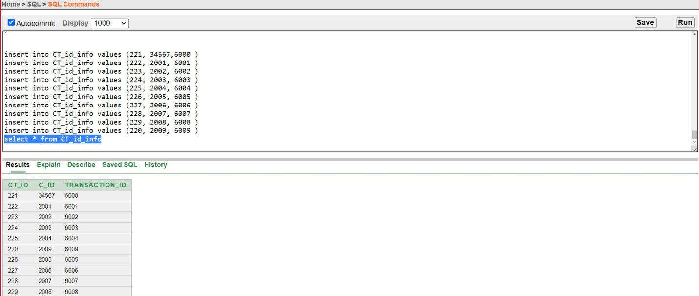

**8.**

insert into food_info values (331, 100, 'RiceBowl', 1, 'Dinner' )  
insert into food_info values (332, 600, 'Burger', 2, 'Platter' )  
insert into food_info values (333, 700, 'Pizza', 2, 'Dinner' )  
insert into food_info (food_id,price,item_name,Type) values (334, 90, 'pepsi', 'Drinks')  
insert into food_info values (335, 100, 'RiceBowl', 1, 'Dinner' )  
insert into food_info values (336, 600, 'Burger', 2, 'Platter' )  
insert into food_info values (337, 700, 'Pizza', 2, 'Dinner' )  
insert into food_info (food_id,price,item_name,Type) values (338, 100, 'COCA COLA', 'Drinks')  
insert into food_info values (339, 700, 'Pizza', 2, 'Platter' )  
insert into food_info values (330, 700, 'pasta', 2, 'Platter' )

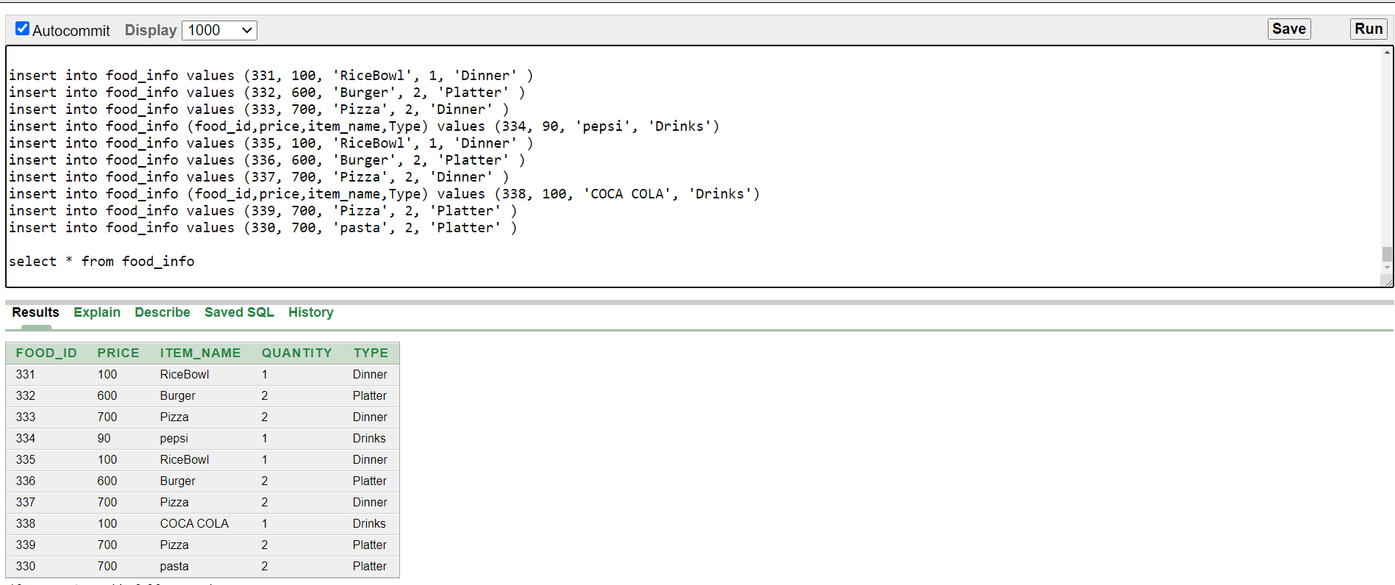

**Subquery:**

**1.Display the item name and type for all customer who ordered more than employee number 2536**

Ans: select item_name,type from food_info where quantity>(select quantity from food_info where food_id= 331 )

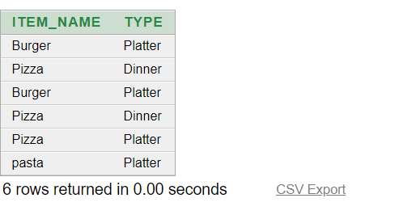

**2. Display the food id and item name for all customers whose price is equal to the price of food id 2345**

Ans: select food_id,item_name from food_info where price = (select price from food_info where food_id = 332)

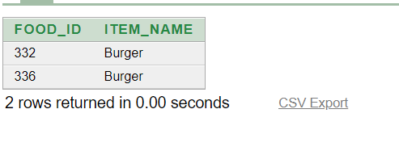

**3.Display the item name and the price of the food where price is higher than the food type named ='Drinks'**

Ans: select item_name,price from food_info where price>(select price from food_info where type = 'Drinks')

**Joining:**

**1.display the customer name, customer id and transaction number**

Ans: select c.name, CT.transaction_id from customer_info c, CT_id_info CT where c.c_id = CT.c_id

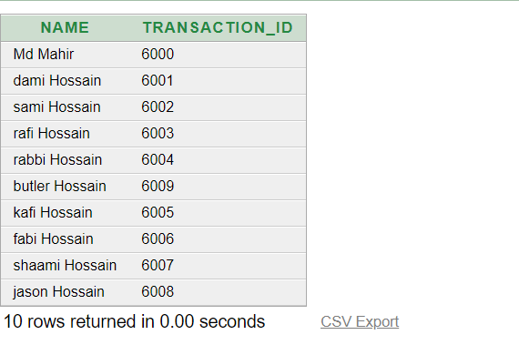

**2. display delivery man name, delivery man e-mail and id**

select d.name, d.email, CD.did from delivery_man_info d, CD_info CD where d.did= CD.did

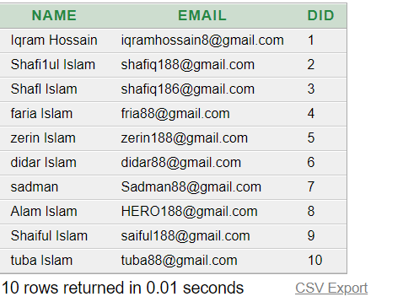

**3. display shop name, shop phone number, TC id and TIN number**

select TIN.TIN_number,TIN.shop_name, TIN.phone_number, TC.TC_id from TIN_info TIN, TC_info TC where TC.TIN_number= TIN.TIN_number

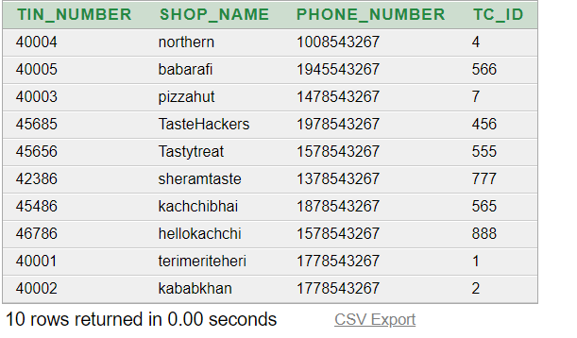

**Group Function:**

**1.Display price and the total price of the food**

Ans: select SUM(price) as "Total Price" from food_info

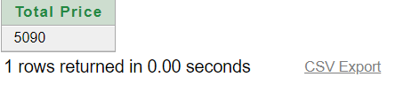

**2. display food number, food type which has ordered by customer and also display the average price**

Ans: select food_id , type, avg(price) from food_info group by food_id, type

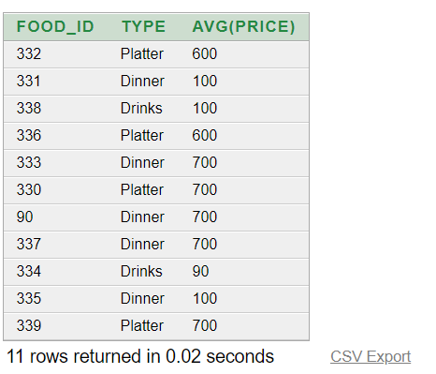

**3.display the maximnum and minimum price of the food which has ordered already by customer**

select max(price) AS "MAXIMUM PRICE" , min (price) AS "MINIMUM PRICE" from food_info

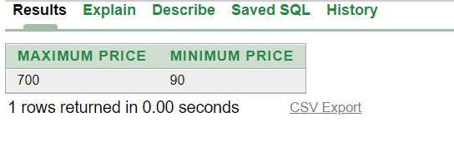

**Single Row Function:**

Q: Write a query to display the customer customer name in upper case, Location, Length of the location

Ans:select UPPER(name) , Location ,length (location) AS "Length of location",

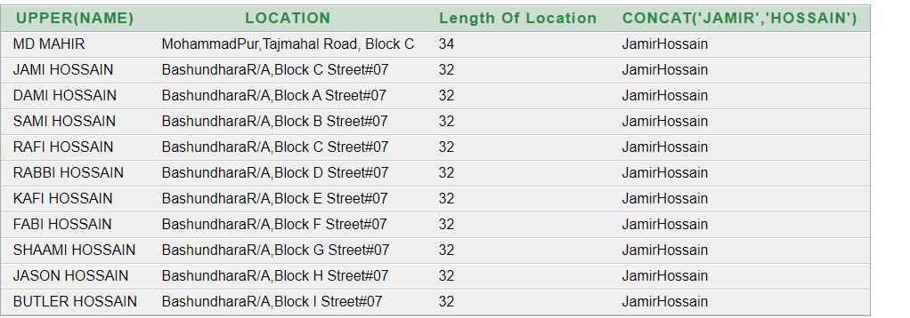

**View:**

1. **Create a view called CUSTM_VU based on the customer id, customer name,phone, number and location from the CUSTOMER_IFO table. .**

Ans: CREATE view CUSTM_VU AS select C_ID, NAME ,PHONE_NUMBER, LOCATION FROM CUSTOMER_INFO

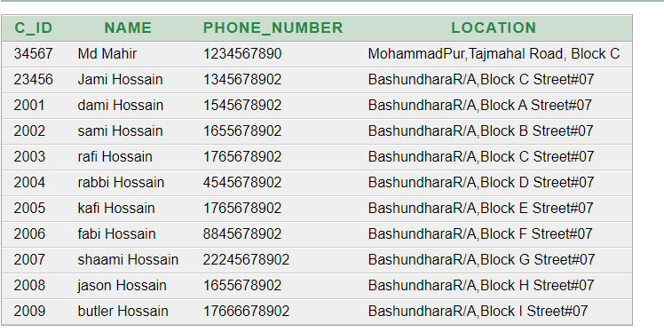

**Sequence:**

Create sequence ordered_food_price

start with 90

maxvalue 700

increment by 1

drop sequence ordered_food_price

insert into food_info (food_id, price, item_name, quantity, type) values (ordered_food_price.nextval,700, 'Pizza', 1, 'Dinner')

